Removing Keyboard and RTC battery
Remove the Keyboard and RTC battery according to the following procedures and Figure 4-8.
- Release the following 13 latches on the keyboard cover, in that order: - One latch on right side and one latch on left sides. - Five bottom latches. - Six front latches.
- Remove the keyboard cover.
- Remove four M2.5x2.5 black flat head screws.
- Disconnect the keyboard cable from CN250 on the system board.
- Remove the keyboard.
- Raise the RTC battery with a plastics stick from the battery locker left hole.
- Remove RTC battery.
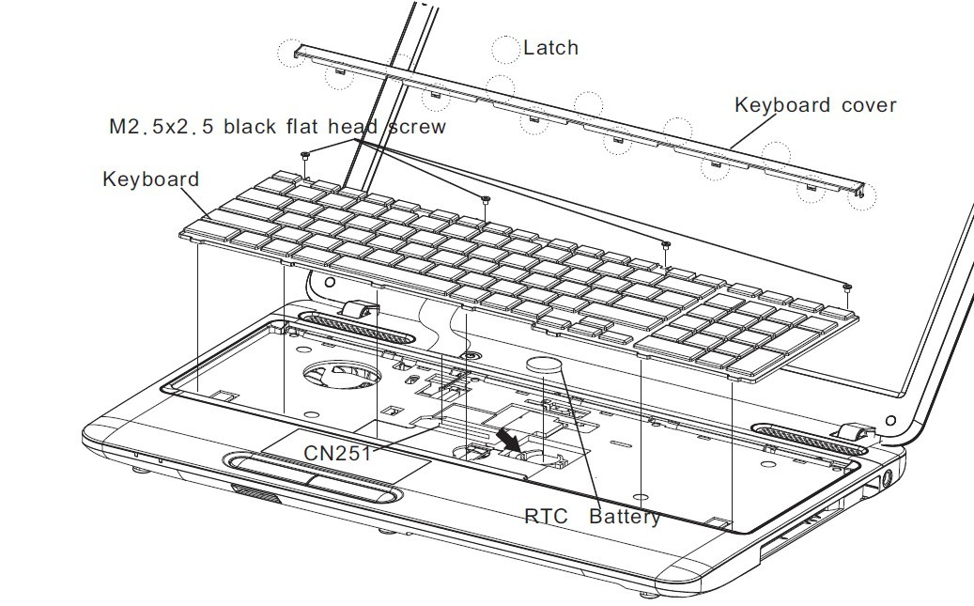

Toshiba Satellite C650, L650, L655, L670, L675, L670D, L675D Series Laptop

